

**CI6225 – Enterprise Application Development**

**Individual Assignment 2**

**User Manual**

**Travel Expense Reimbursement Application**

**V2.0**

|  |
| --- |
| SU SHIJIAN (GXXXXXXXX) |

12 Apr 2014

Contents

1. Introduction 4

1.1 User Types 4

1.2 Modules and Functions 4

2. Common User Module 6

2.1 Sign In 6

2.2 Remember Me 6

2.3 Edit Password 6

2.4 Expire Remember Me 7

2.5 Sign Out 7

2.6 Unknown Error Handling 7

2.7 Page Not Found Handling 7

3. Dashboard 8

3.1 View Current User & Department Information 8

3.2 View Claim Form Pending Approval Information 8

3.3 View Claim Form for You Approval 9

3.4 Department Approval 9

3.5 Financial Approval 9

3.6 Reject 9

4. Maintain User 10

4.1 View User List 10

4.2 Create New User 11

4.3 Update User 12

4.4 View User 12

4.5 Remove User 13

5. Maintain Department 14

5.1 View Department List 14

5.2 Create New Department 14

5.3 Update Department and Maintain Department User 15

5.4 View Department 15

5.5 Remove Department 16

6. Maintain Claim Form 17

6.1 View Your Claim Form List 17

6.2 View Approval Manager and Department Information 17

6.3 Create New Claim Form 18

6.4 Update Claim Form and Maintain Items 18

6.5 View Claim Form 19

6.6 Remove Claim Form 20

6.7 Submit Claim Form 20

7. Monitor Claim Form 21

7.1 View All Claim Forms List 21

8. Report 22

8.1 View Report List 22

8.2 Preform Report 22

8.2.1 Preform Report (Simple Type) 23

8.2.2 Preform Report (Complex Type) 23

8.3 Download Report 24

# 1. Introduction

Travel Expense Reimbursement Application v2.0 is an application that you can manage the Travel Expense Reimbursement information.

Once the application is up, you can test by URL:

<http://localhost:8080/ntu-is-ead-tera-v2>

User Name: isadmin

Password: root

## 1.1 User Types

There are types of user in this application:

1) Normal User (a.k.a U):

All users are belonging to normal user.

2) System Administrator (a.k.a.SA):

In “maintain user” edit user model, if “is Administrator” flag is Y, then this user is an administrator user.

3) Department Manager (a.k.a DM):

In “maintain department” edit department model, if user assigned to “Manager”, then this user is a department manager. The manager depend department; each department only can have one manager.

4) Finical Department User (a.k.a FD):

In “maintain department” edit department model, if user assigned to a department, which its “Operation Area” is with “is Financial” flag Y, then this user is account user.

Some testing accounts are as below:

|  |  |  |  |  |  |
| --- | --- | --- | --- | --- | --- |
| User  Name | Password | Is Normal  User | Is System Administrator | Is Department  Manager | Is Finical Department User |
| isadmin | root | Y | Y | Y | N |
| account-user1 | root | Y | N | N | Y |
| account-user2-manager | root | Y | N | Y | Y |

There is a user type is as below:

Approver (a.k.a AP):

Included Department Manager and Finical Department User

## 1.2 Modules and Functions

**1) Common User Module**

(1) Sign In

(2) Remember Me

(3) Edit Password

(4) Expire Remember Me

(5) Sign Out

(6) Unknown Error Handling

(7) Page Not Found Handling

**2) Dashboard**

(1) View Current User & Department Information

(2) View Claim Form Pending Approval Information

(3) View Claim Form for You Approval (For AP User only)

(3.1) Department Approval (For DM User only)

(3.2) Financial Approval (For FD User only)

(3.3) Reject (For AP User only)

(4)  Recent One Year Personal Approved Claimed Amount

**3) Maintain User (For SA only)**

(1) View User List

(2) Create New User

(3) Update User

(4) View User

(5) Remove User

**4) Maintain Department (For SA only)**

(1) View Department List

(2) Create New Department

(3) Update Department and Maintain Department User

(4) View Department

(5) Remove User

**5) Maintain Claim Form**

(1) View Your Claim Form List

(1.1) Claim Form List (Saved & Rejected)

(1.2) Claim Form List (Submitted)

(1.3) Claim Form List (Department Approved)

(1.4) Claim Form List (Financial Approved)

(2) View Approval Manager and Department Information

(3) Create New Claim Form

(4) Update Claim Form and Maintain Items

(4.1) Update for Saved Status Claim Form

(4.1) Update for Rejected Status Claim Form

(5) View Claim Form

(6) Remove Claim Form

(7) Submit Claim Form

**6) Monitor Claim Forms (For FD User only)**

(1) View All Claim Forms List

**7) Report**

(1) View Report List

Individual Claim Summary Report

Individual Claim Items Report

(2) Preform Report

There is Simple Type and Complex Type

View and select all users, For FD User only. Other only can see himself.

(3) Download Report

# 2. Common User Module

## 2.1 Sign In

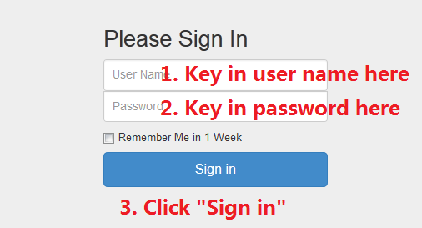

## 2.2 Remember Me

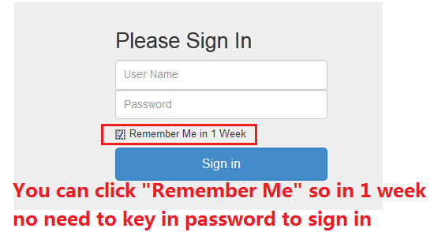

## 2.3 Edit Password

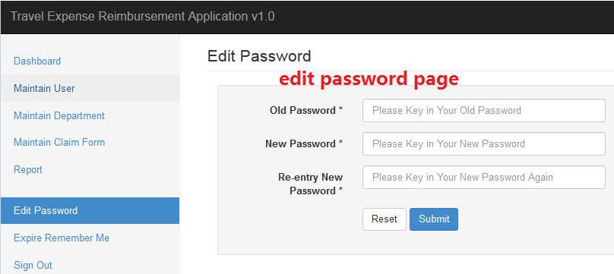

## 2.4 Expire Remember Me

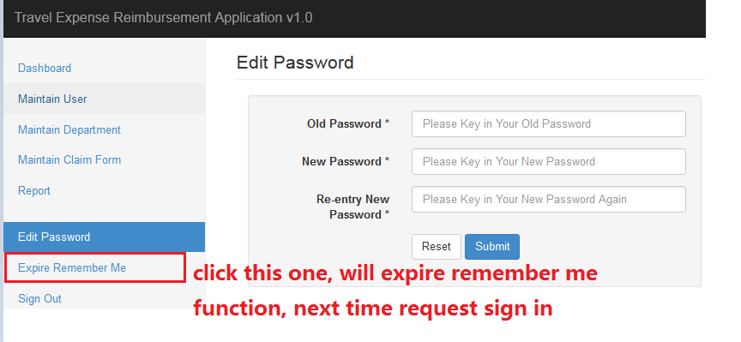

## 2.5 Sign Out

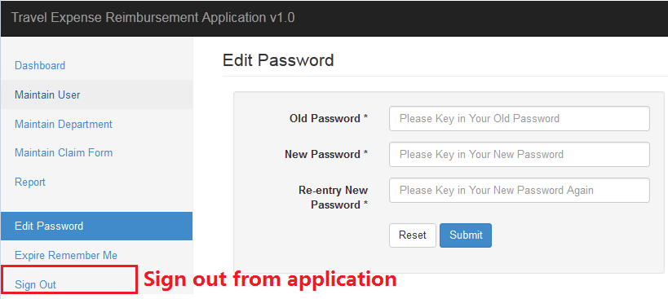

Then will go to this page after sign out



## 2.6 Unknown Error Handling

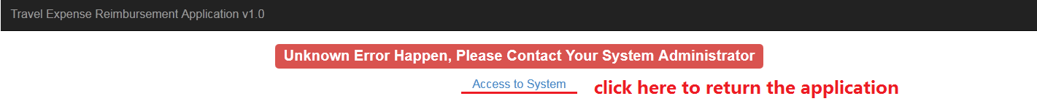

## 2.7 Page Not Found Handling



# 3. Dashboard

## 3.1 View Current User & Department Information

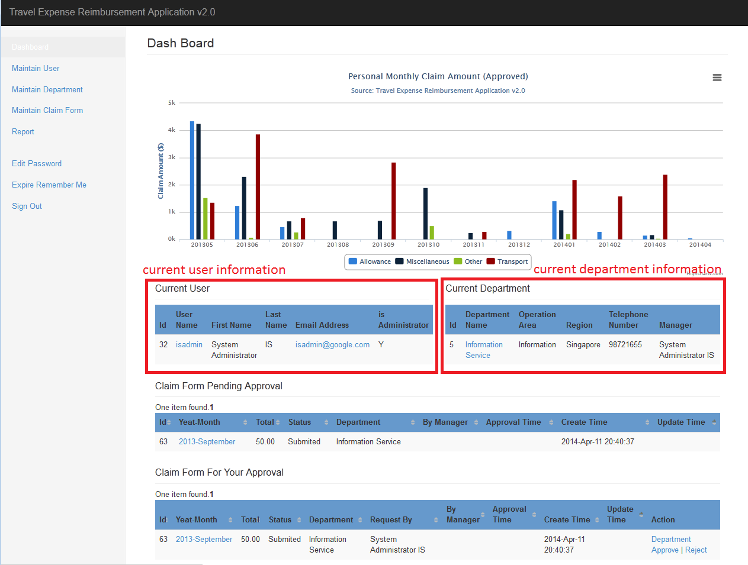

## 3.2 View Claim Form Pending Approval Information

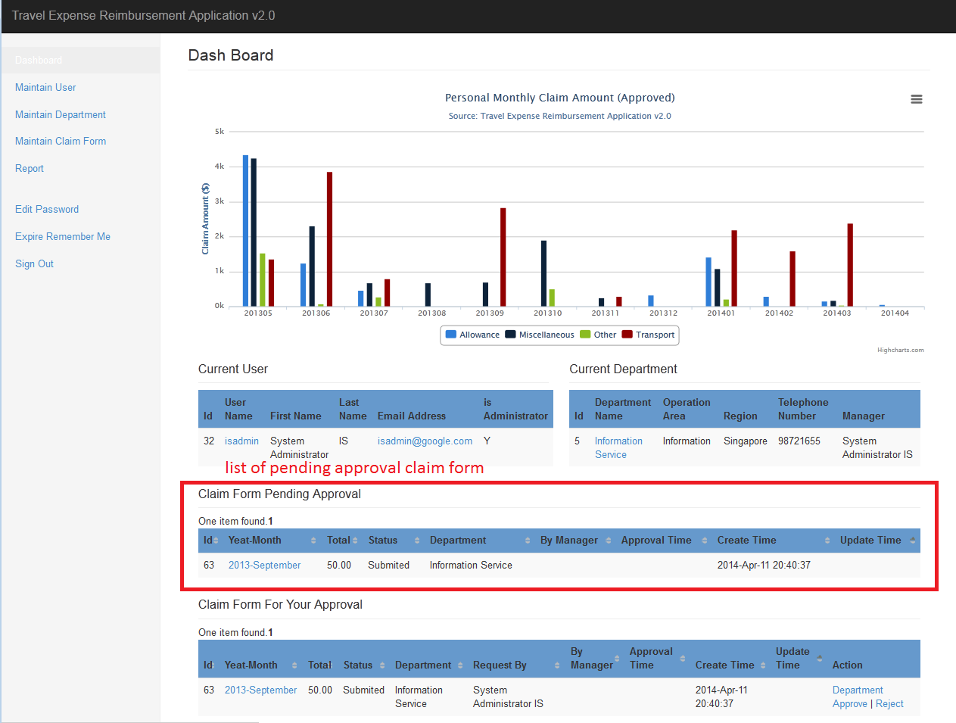

## 3.3 View Claim Form for You Approval

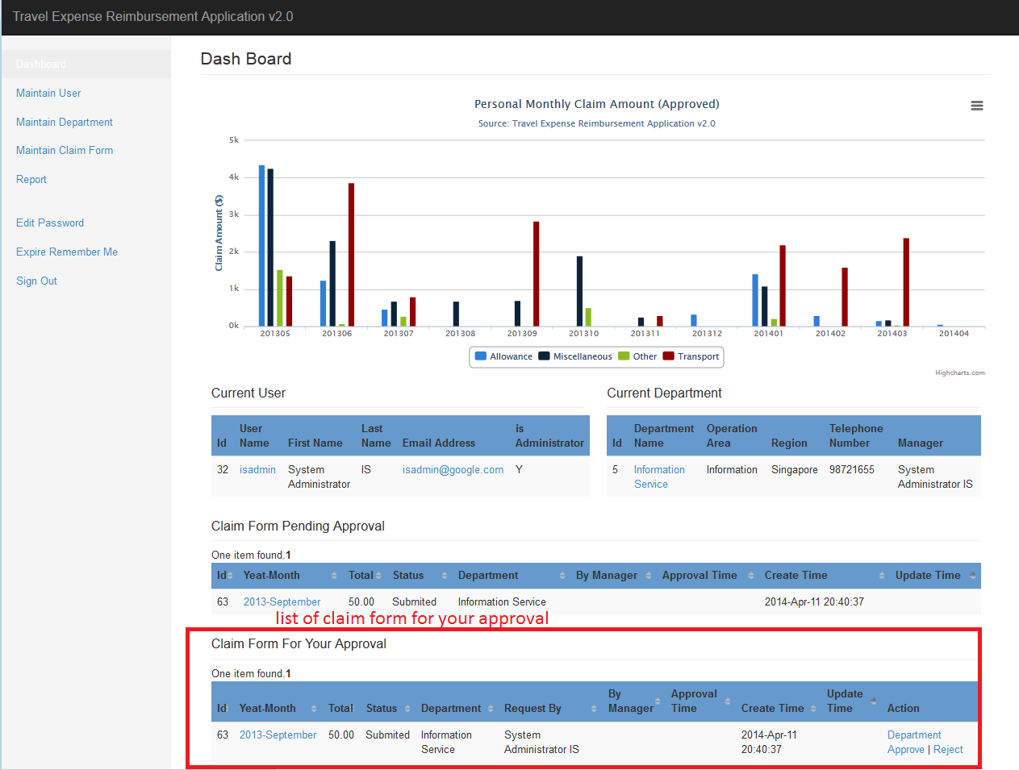

## 3.4 Department Approval

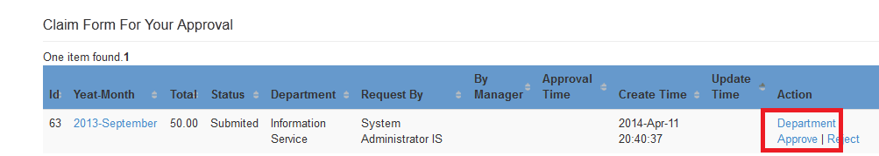

## 3.5 Financial Approval

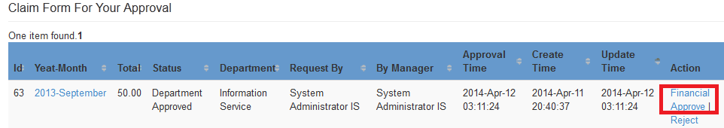

## 3.6 Reject

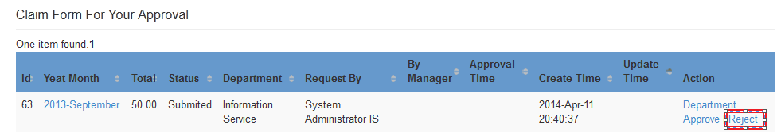

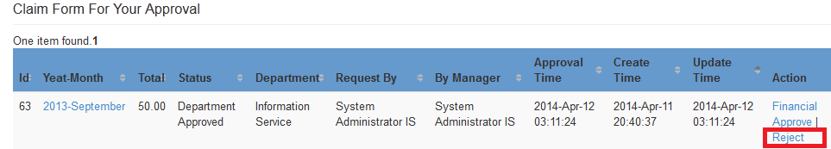

# 4. Maintain User

## 4.1 View User List

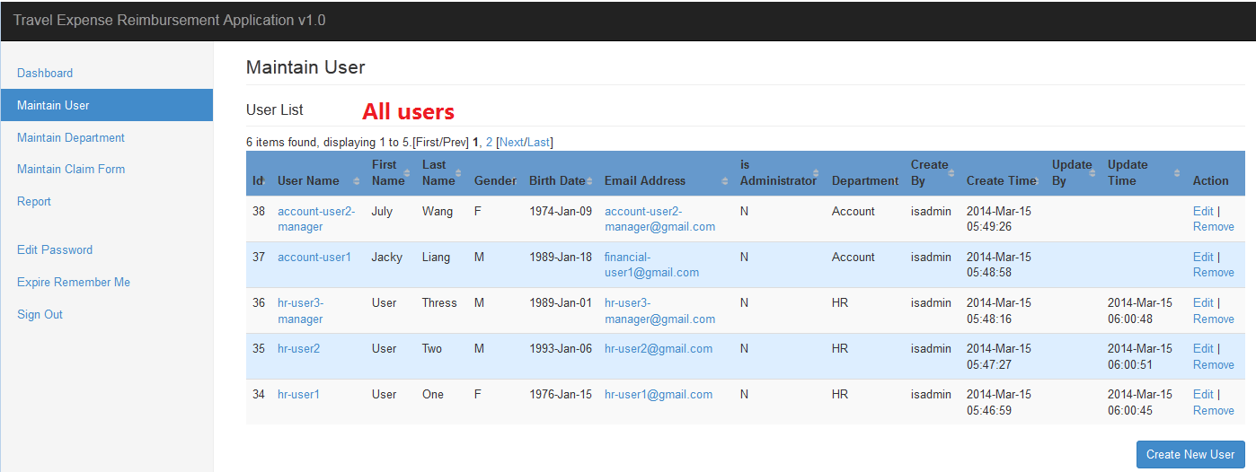

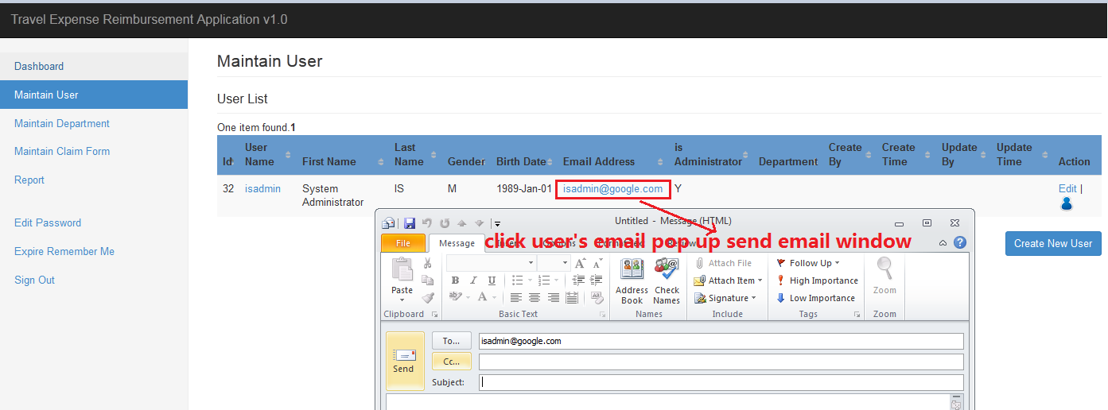

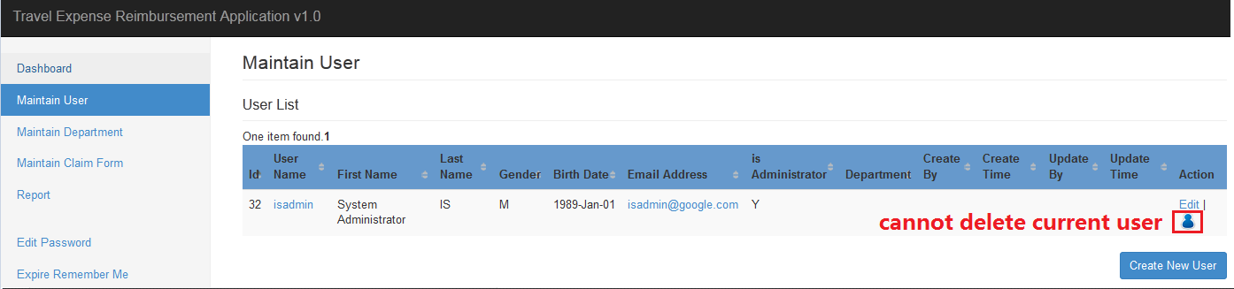

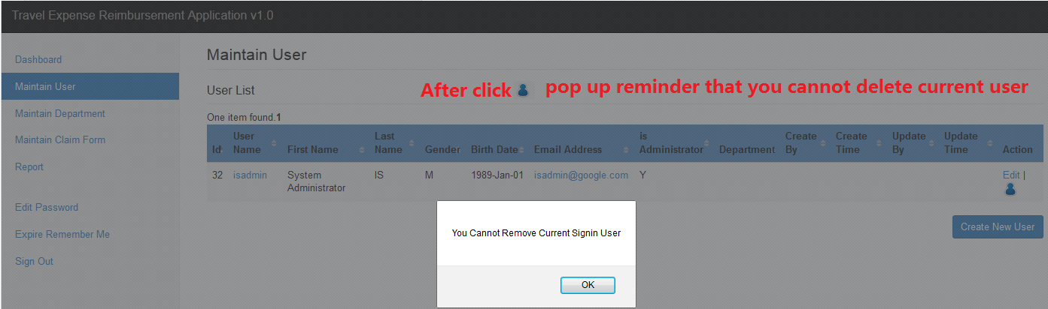

## 4.2 Create New User

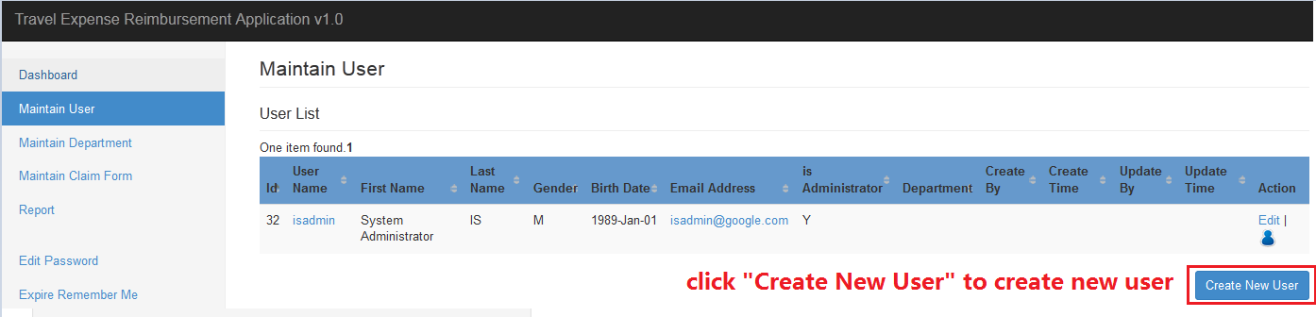

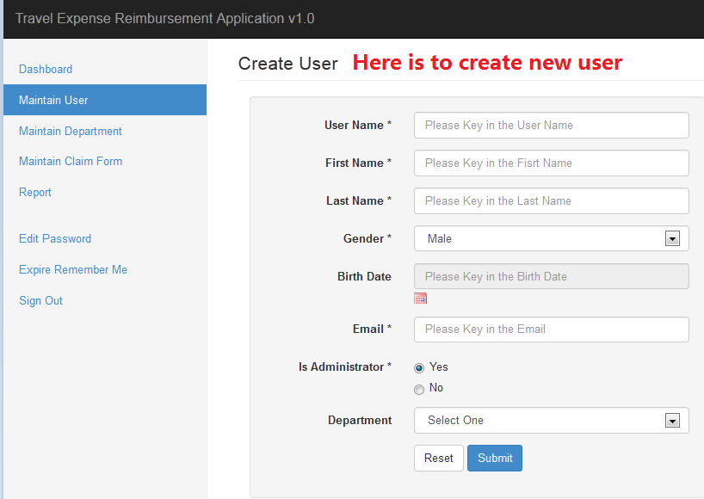

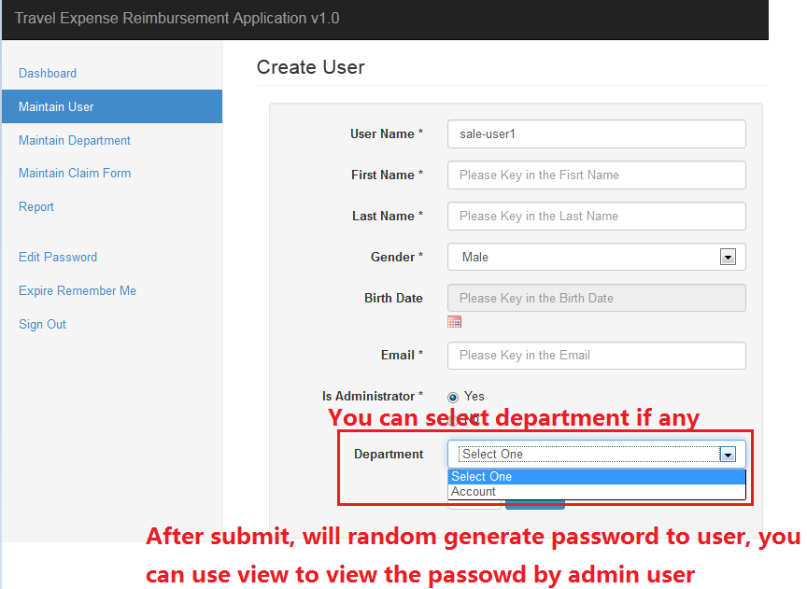

## 4.3 Update User

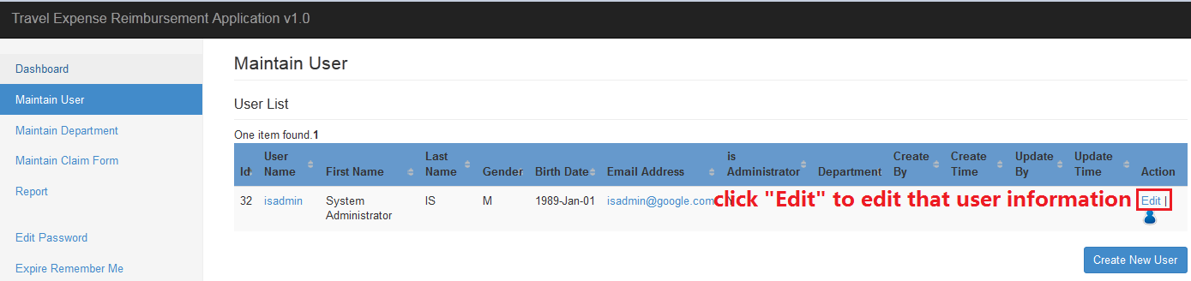

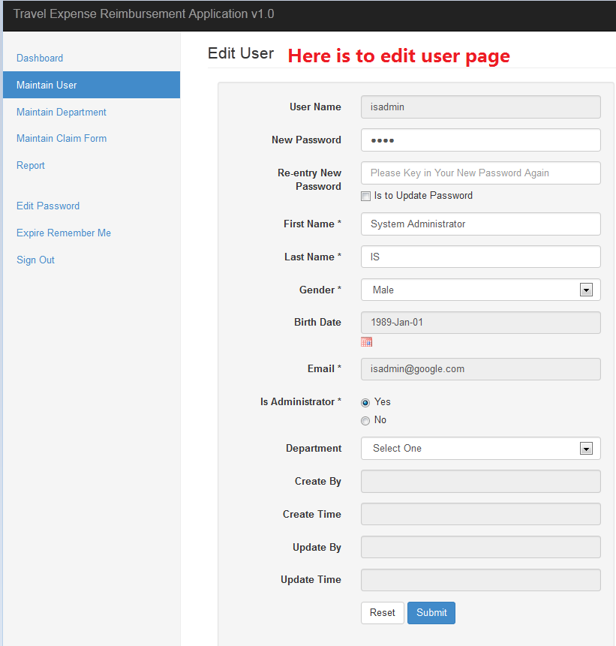

## 4.4 View User

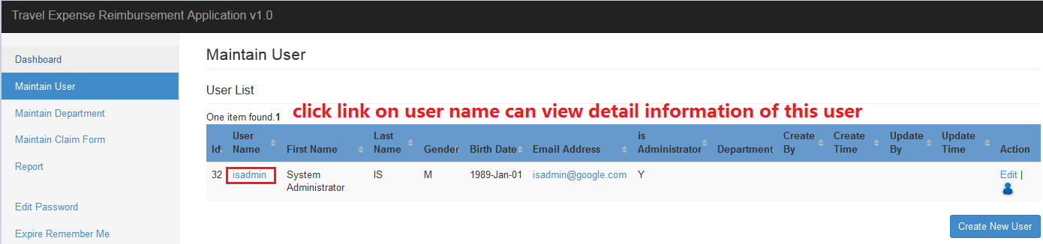

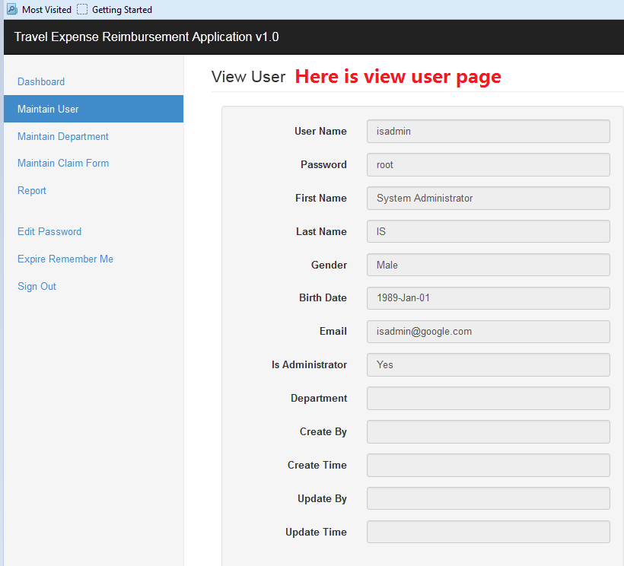

## 4.5 Remove User

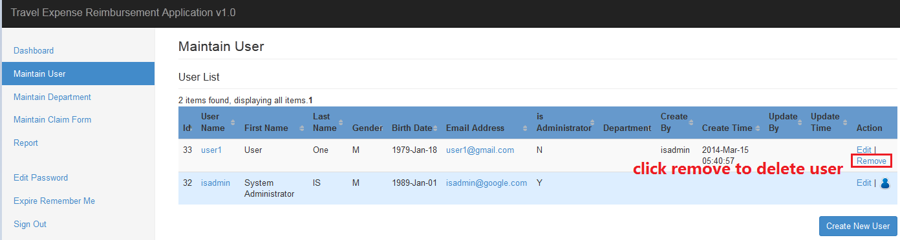

# 5. Maintain Department

## 5.1 View Department List

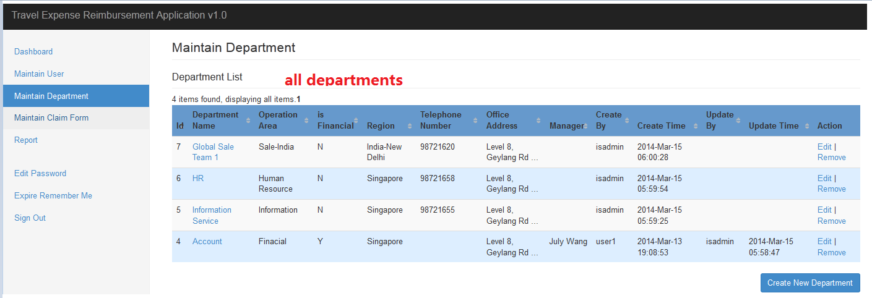

## 5.2 Create New Department

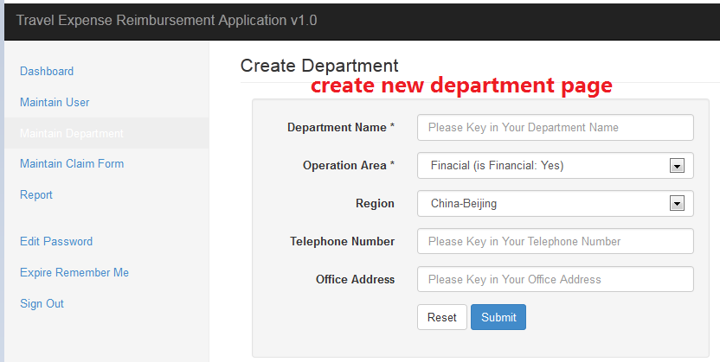

## 5.3 Update Department and Maintain Department User

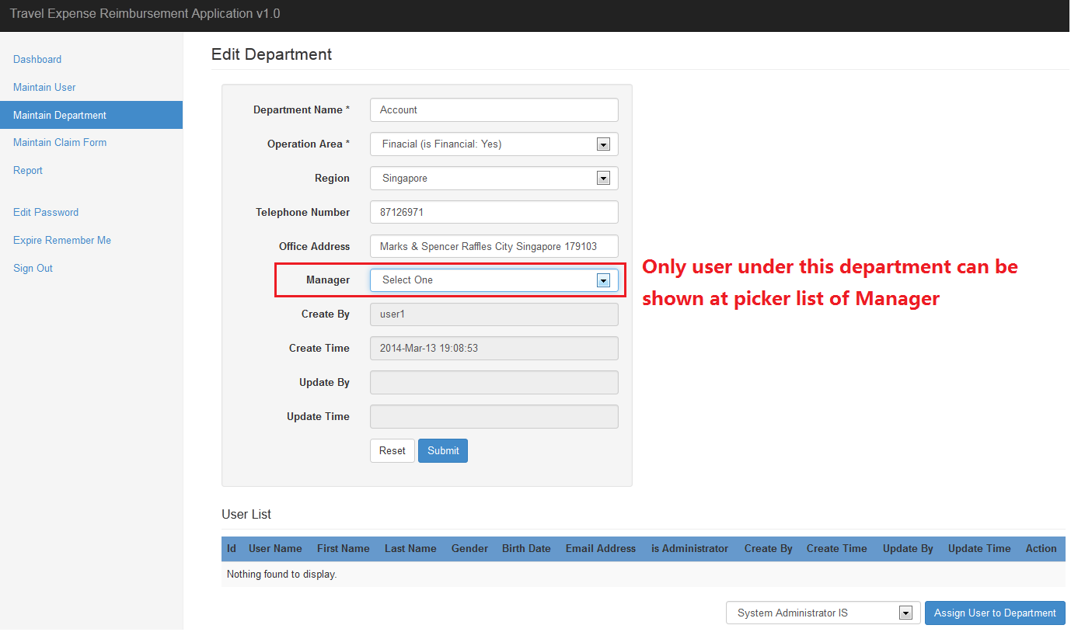

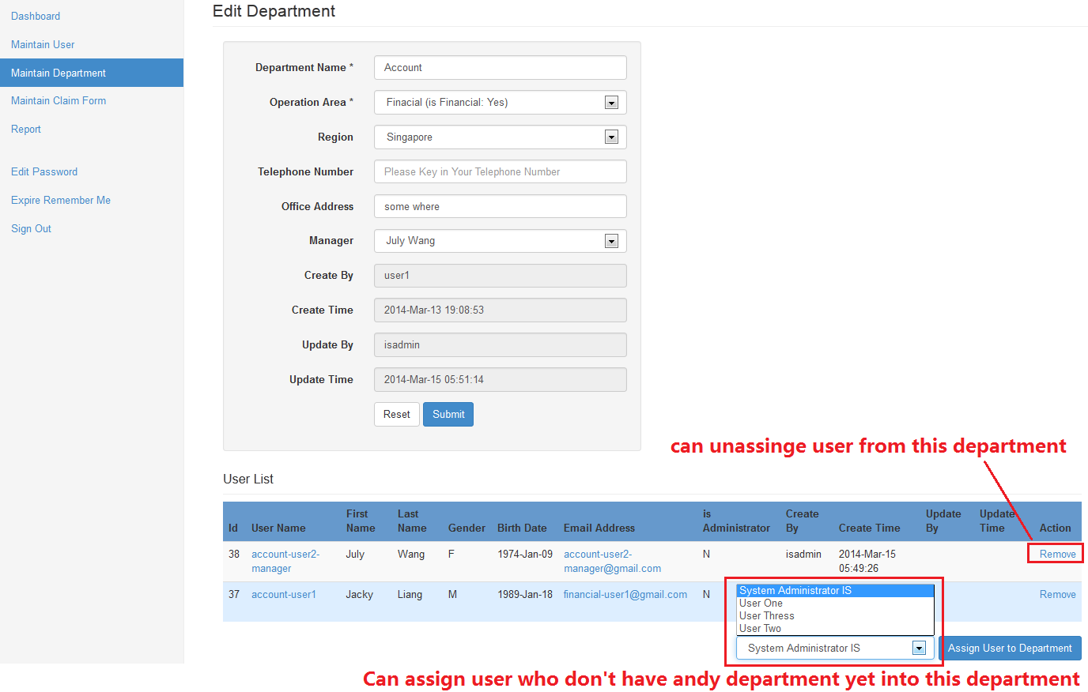

## 5.4 View Department

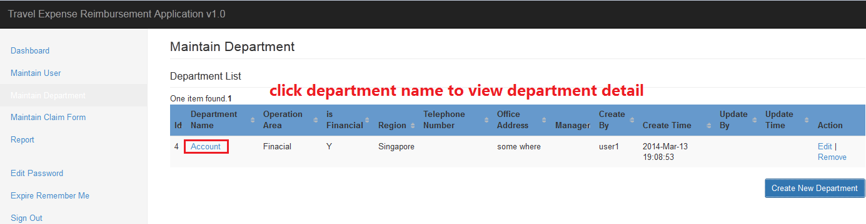

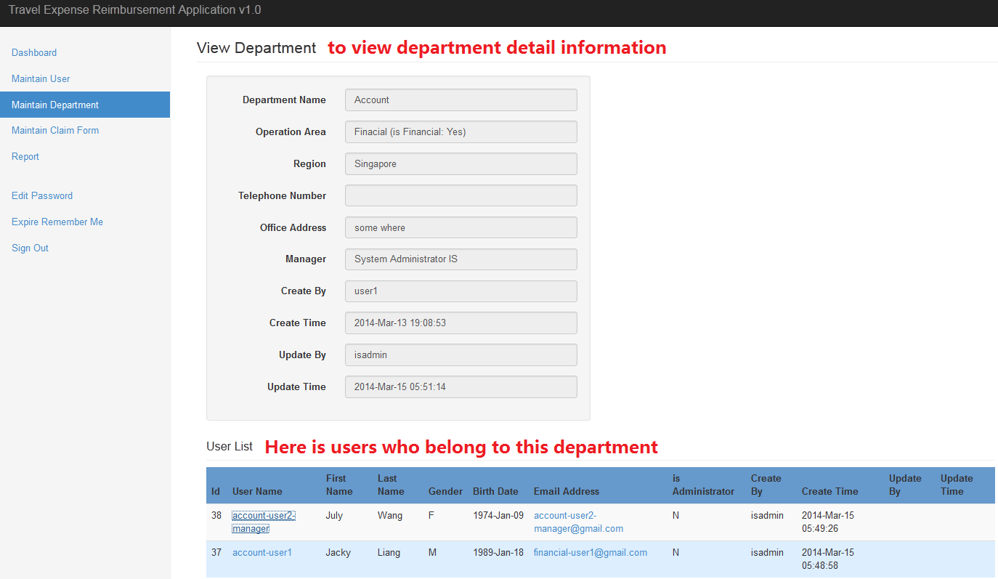

## 5.5 Remove Department

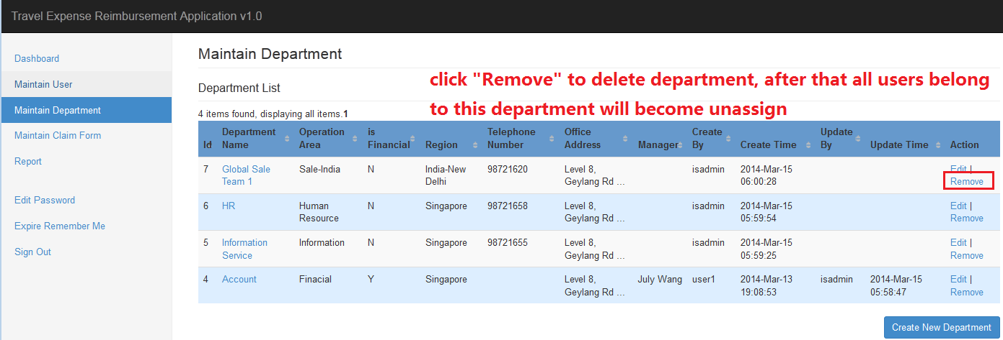

# 6. Maintain Claim Form

## 6.1 View Your Claim Form List

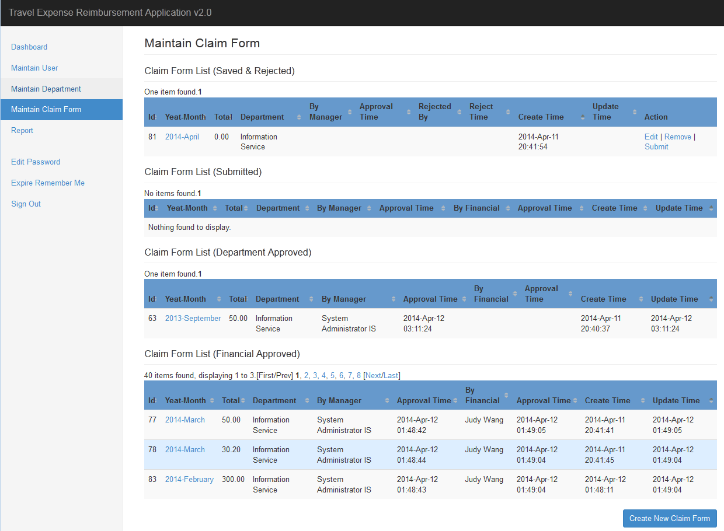

## 6.2 View Approval Manager and Department Information

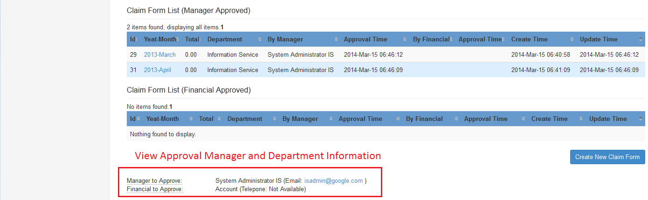

## 6.3 Create New Claim Form

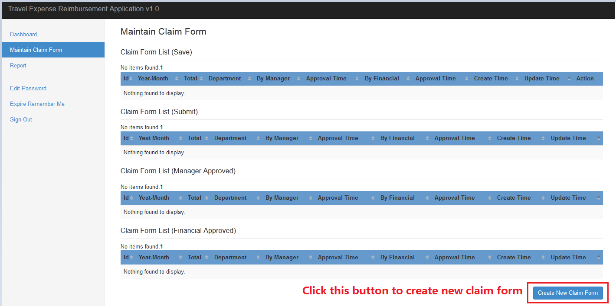

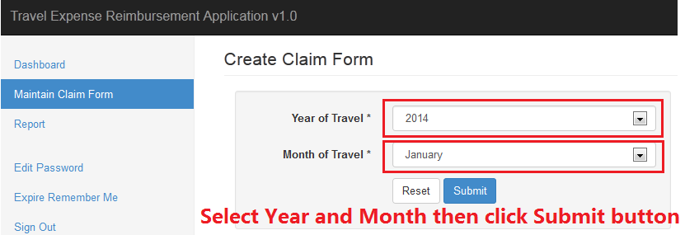

## 6.4 Update Claim Form and Maintain Items

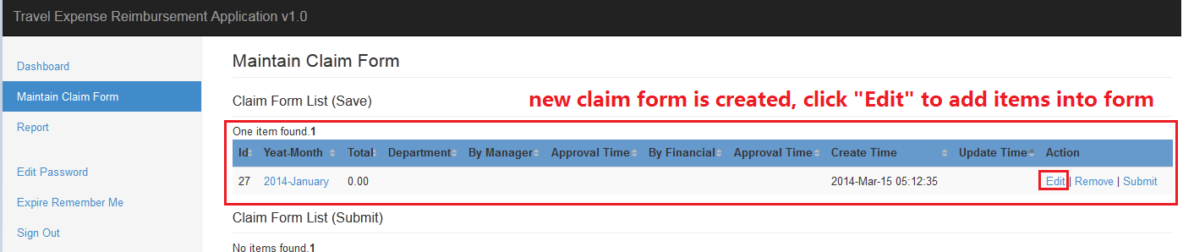

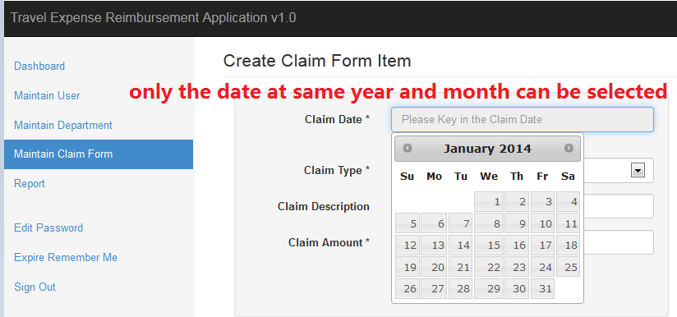

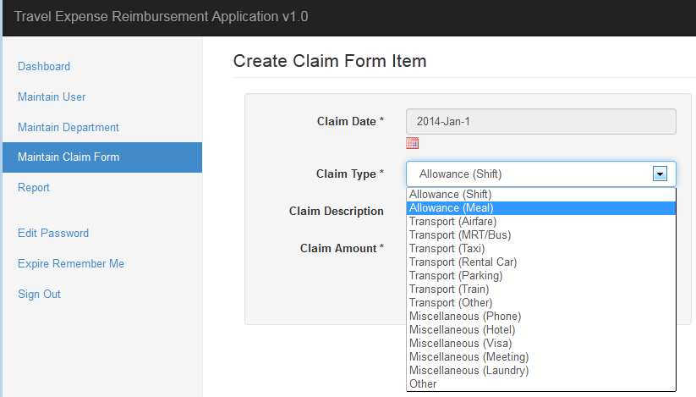

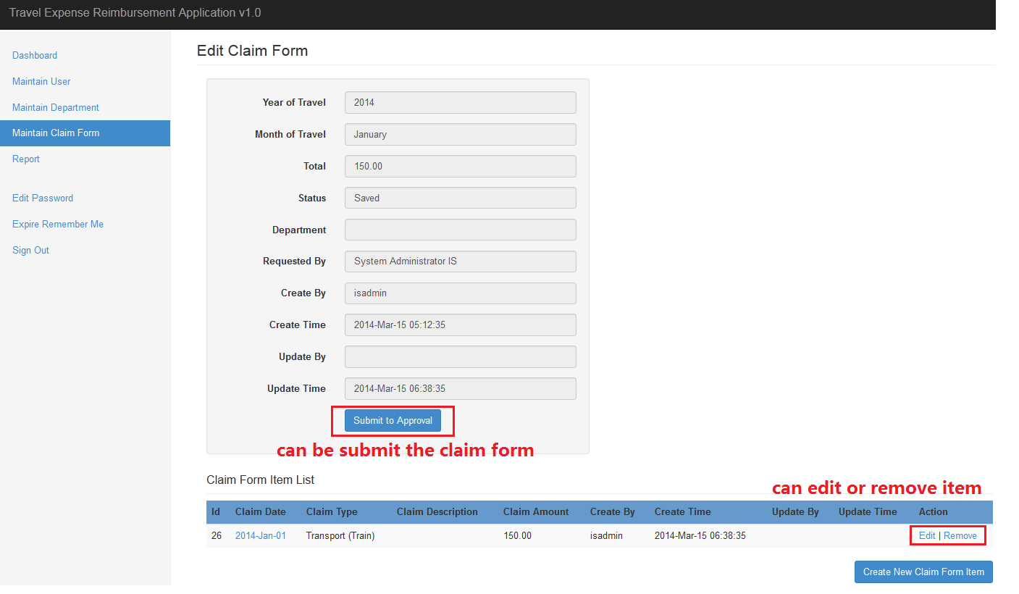

## 6.5 View Claim Form

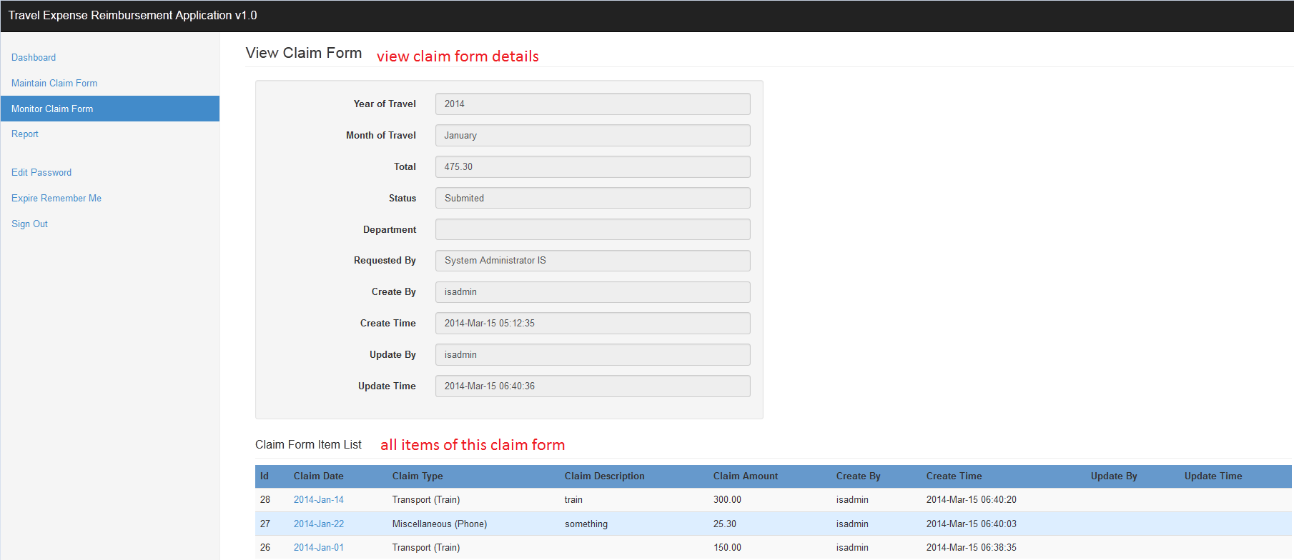

## 6.6 Remove Claim Form

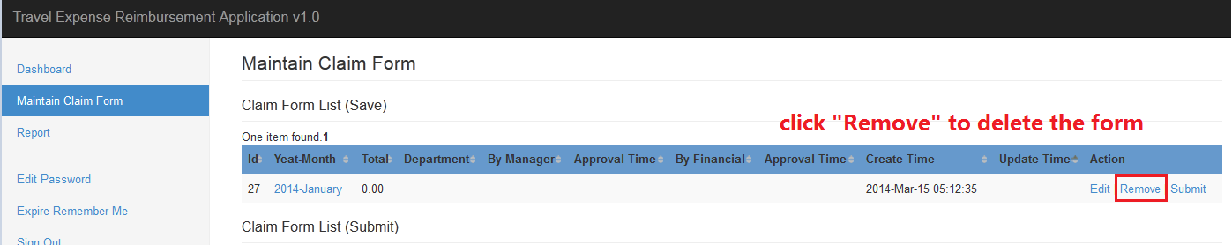

## 6.7 Submit Claim Form

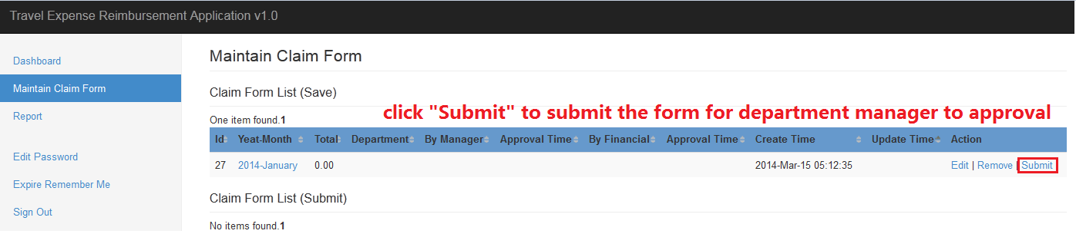

# 7. Monitor Claim Form

## 7.1 View All Claim Forms List

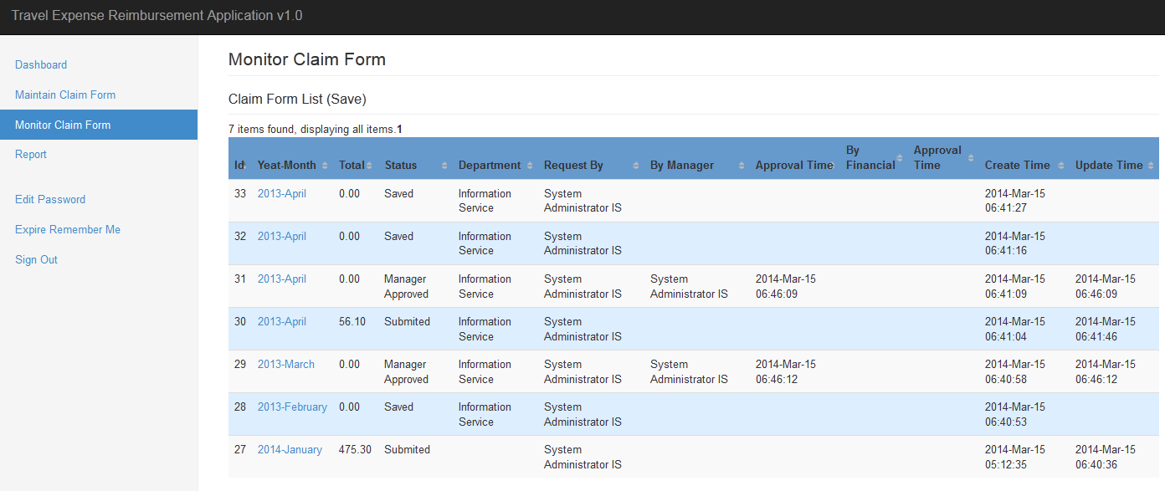

# 8. Report

## 8.1 View Report List

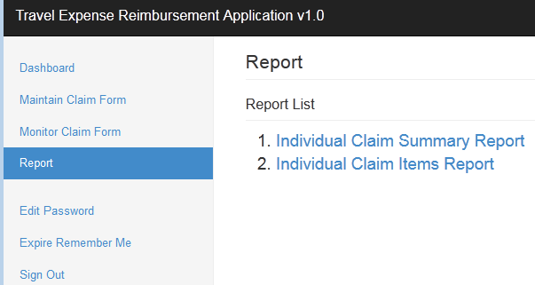

## 8.2 Preform Report

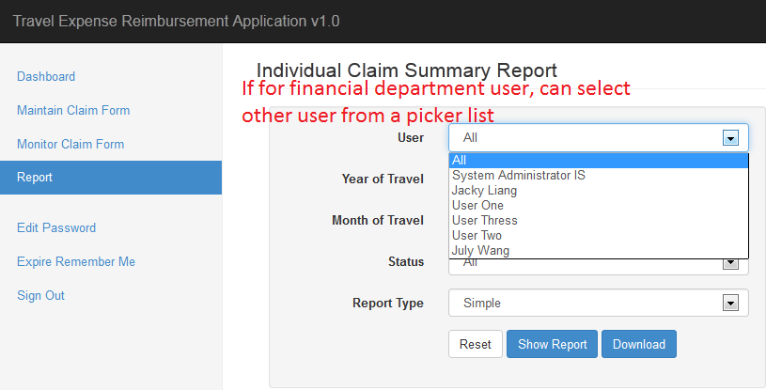

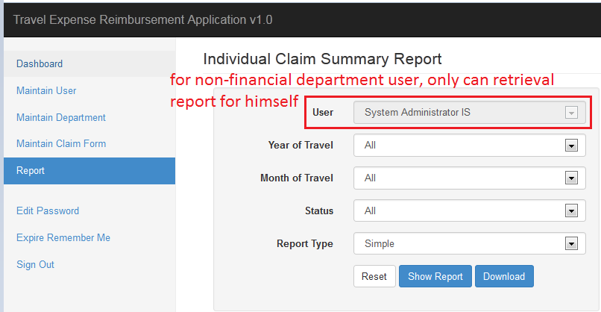

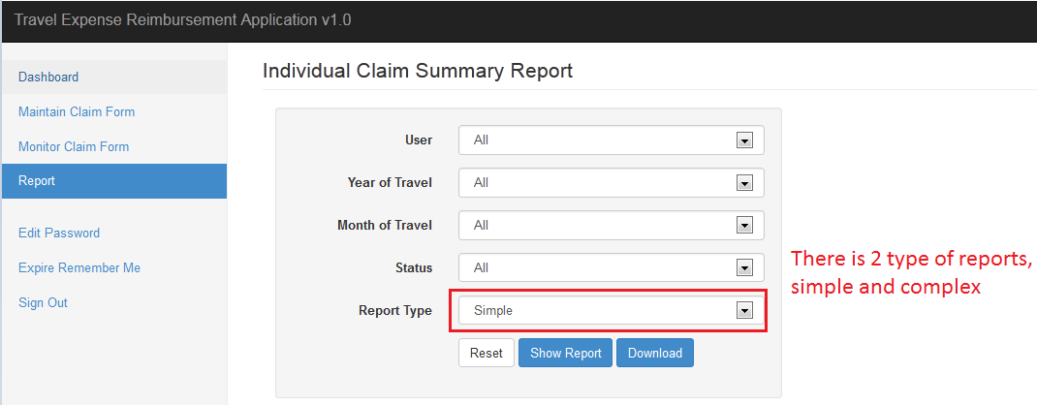

### 8.2.1 Preform Report (Simple Type)

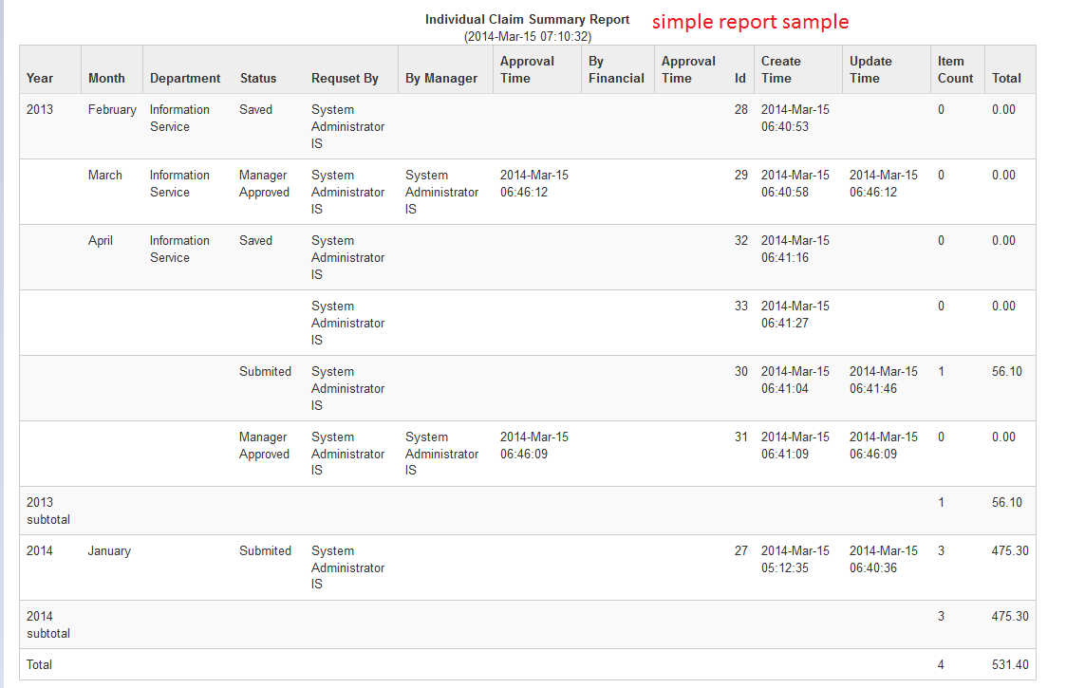

### 8.2.2 Preform Report (Complex Type)

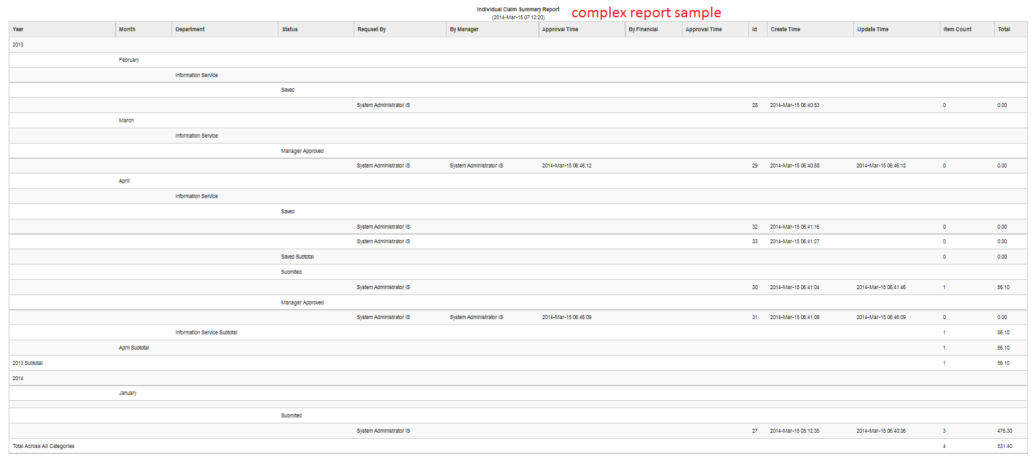

## 8.3 Download Report

